**OVERVIEW & LIFE CYCLE**

**Course Overview**

* Reinforcement learning
* Supervised learning
* Unsupervised learning
* Regression & classification models
* Clustering methods
* Hidden Markov models
* Sequential models

**Introduction**

* **ML** was first termed by **Arthur Samuel** in **1959**.

**Features of ML**

* We code only the **formula**, **not everything**; for prediction.
* ML must be able to **detect** various pattern.

**Understanding Necessity**

* **Cost function:** **Performance** of a model as per given **dataset**.

**Classification of ML**

* Supervised learning
* Unsupervised learning
* Reinforcement learning

**Supervised Learning**

* Models predict outcome by using **sample data**; provided by the trainers.
* After providing the sample data, the models are tested for its accuracy.

Types of supervised learning:-

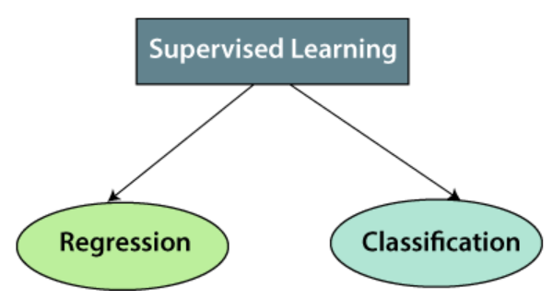

**Unsupervised Learning**

* In this, we **don’t tell** model about which **pattern** to use for prediction.
* The model recognizes the pattern **itself**.
* Its goal is to recognize & form accurate custom patterns.

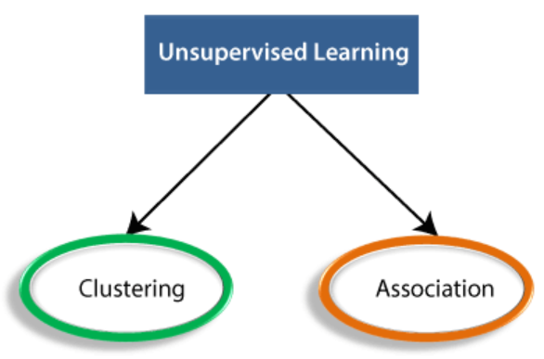

**Reinforcement Learning**

* It’s a **feedback based** learning method.
* The model is given points for its accuracy.
* It learns from its **mistakes** and becomes better over time.

**Prerequisites**

* Probability
* Linear algebra
* Programming language (any)
* Calculus

**ML Life Cycle**

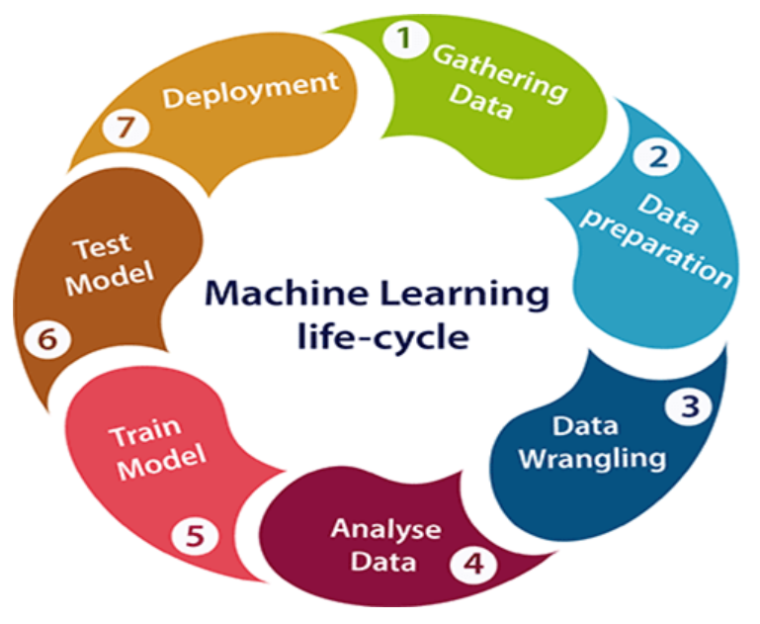

**Gathering Data**

* **Quantity** and **quality** of data will determine the **accuracy** of output.
* During this phase, first the **data sources are chosen**.
* Then data are **fetched** from those sources.
* And finally, these data are **added to our dataset**.

**Data Preparation**

* Fetched data are **randomized** in the dataset.
* Then a **quality analysis** is done on data.
* After that we look for a **pattern** in data.

**Data Wrangling**

* It is **conversion** of collected **raw data** into a **useful information**.
* And it also includes **cleansing of data** i.e. **filtering** in the useful data.
* The **unrequired data** filtered out may contain **duplicate data** & **invalid data** etc.

**Data Analysis**

* Now the cleaned data is **passed** for analysis.
* For analysis, first a proper **technique is selected** for it.
* Then our desired model is **built**.
* And then our result is passed for **review**.

**Train Model**

* We **feed more** dataset to the model, to **increase its accuracy**.

**Test Model**

* Then testing is done to check the **accuracy**, **speed** & **error** etc of our model.
* On the basis of test results, the model either **modified** or **rejected** if it **doesn’t** meet the requirements of the project.

**Deployment**

* It is making the product **available** for the users.
* A **build version** is provided to the model before releasing the product.

**Artificial Intelligence v/s Machine Learning**

* Types of AI: **Weak**, **general** & **strong**.
* Current era is of **general AI**.
* ML is about **extracting knowledge** from data.

|  |  |
| --- | --- |
| **Artificial Intelligence** | **Machine Learning** |
| **Can perform various tasks.** | **Trained for a particular task.** |
| **It is concerned about solving a problem.** | **It is concerned about providing accurate output.** |
| **It learns without being provided with data.** | **It learns only when provided with data.** |
| **AI deals with:**   * **Structured data** * **Semi-structured data** * **Unstructured data** | **ML deals with:**   * **Structured data** * **Semi-structured data** |